Mobile Voting Application

Software Development Plan

Version 1.0.0

Group 2

Zachary Bugay

Jamie Min

Revision History

|  |  |  |  |
| --- | --- | --- | --- |
| **Date** | **Version** | **Description** | **Author** |
| 12 Feb 2018 | 0.1.0 | Initial documentation write-up | Prepared by Jamie Min |
| 29 Mar 2018 | 1.0.0 | Final documentation write-up | Prepared by Jamie Min |
|  |  |  |  |
|  |  |  |  |

Table of Contents

**1.** **Scope 4**

*1.1* *Functions 4*

*1.2* *Performance 4*

*1.3* *Limitations 4*

**2.** **Task Overview 5**

*2.1* *Project Purpose, Scope, and Objectives 5*

*2.2* *Assumptions and Constraints 5*

*2.3* *Evolution of the Software Development Plan 5*

**3.** **Resources 5**

*3.1* *Hardware 5*

*3.2* *Software 5*

*3.3* *Roles and Responsibilities 6*

**4.** **Cost 7**

**5.** **Project Schedule 8**

# Scope

**Mobile Voting Application** is a collaborative-based social media platform that offers a unique opportunity for individuals to vote for their favorite poster.

The application will primarily target University of Pittsburgh students.

## Functions

This section of the *Software Development Plan* is to gather all information necessary to outline the capabilities of the project. It describes the needs and approaches to the development of the software and is the top-level plan generated and used by managers to direct the development of the functions in this project.

**Mobile Voting Application** will include the following core functions with the necessary resources to support it:

* Allow users to vote for their favorite poster via cell phone.

## Performance

This section of the *Software Development Plan* describes the overall anticipated performance of **Mobile Voting Application**, including deployment of the product.

* System should be able to handle at least 200 concurrent users
* System should be able to handle and store at least five hundred thousand user profiles
* System should process webpages and inquiries in a reasonable time
* All process requests should be handled in a reasonable time

## Limitations

This section of the *Software Development Plan* reviews the limitations and design constraints of **Mobile Voting Application.**

* The system will only be able to handle University of Pittsburgh students and faculty.
* The system will need users to have a cell phone that can submit text messages.

# Task Overview

## Project Purpose, Scope, and Objectives

This section of the *Software Development Plan* will cover the project purpose and the projected tasks that will need to be completed.

The main tasks the project team will need to focus on are:

* User interface design
* Database implementation
* Server implementation
* Profile management
* User authentication

## Assumptions and Constraints

This section reviews assumptions and constraints that apply to the project.

The project team consists of University of Pittsburgh students. Development constraints will be dependent on individual schedules, work load, and technical capabilities.

## Evolution of the Software Development Plan

The *Software Development Plan* will be revised prior to the start of the first Iteration phase to reflect the necessary changes.

This document will also be revised as needed in accordance to the software schedule.

# Resources

This section of the *Software Development Plan* will go over hardware and software resource need for the development of the project.

## Hardware

* Computer and necessary peripherals
* Weekly meeting space
* Internet connection
* Local server

## Software

* Java
* Relevant backend frameworks
* HTML/CSS/JS
* Relevant frontend frameworks
* Google Chrome, Mozilla Firefox, Internet Explorer
* SIS

## Roles and Responsibilities

|  |  |  |
| --- | --- | --- |
| **Person** | **Role** |  |
| Zachary Bugay, Senior | Group Leader  Project Manager  Sales  GUI Testing  Functional Testing  Unit Testing  Integration Testing  Documentation |  |
| Jamie Min, Senior |  | Functional Testing  Sales |

|  |  |  |
| --- | --- | --- |
|  | Zachary Bugay | Jamie Min |
| Project Manager | X |  |
| Documentation |  | X |
| GUI Engineer |  | X |
| Database Admin | X |  |
| App Engineer | X | X |
| Unit Testing | X |  |
| Integration Testing |  | X |
| GUI Testing | X |  |
| Functional Testing | X |  |
| Sales | X | X |

Anyone on the project can perform other activities.

# Cost

This section of the *Software Development Plan* is the cost. The cost is subject to change, and to be updated as necessary to ensure quality of the product, and to ensure it is completed on time free of issues.

# Project Schedule

This section of the *Software Development Plan* is the schedule. The schedule is subject to change, and to be updated as necessary to ensure quality of the product, and to ensure it is completed on time free of issues.

# Data Diagrams

This section of the *Software Development Plan* will cover the data diagrams used to represent a top-level overview of the data flow used in the voting component.

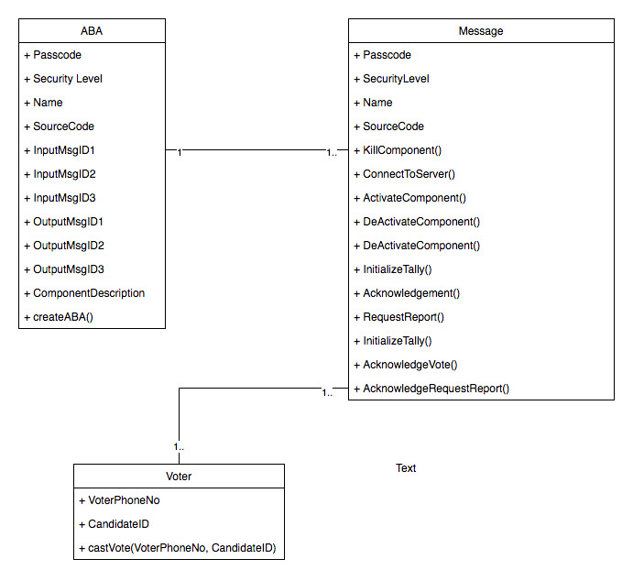

Figure - Class Diagram

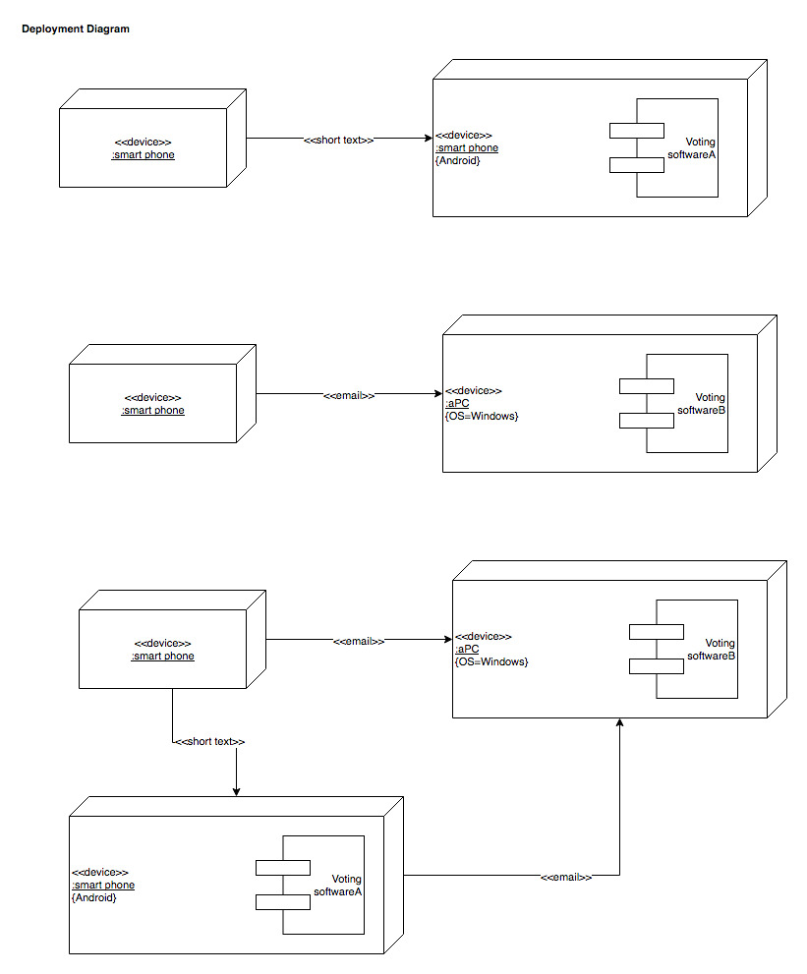

Figure - Deployment Diagram

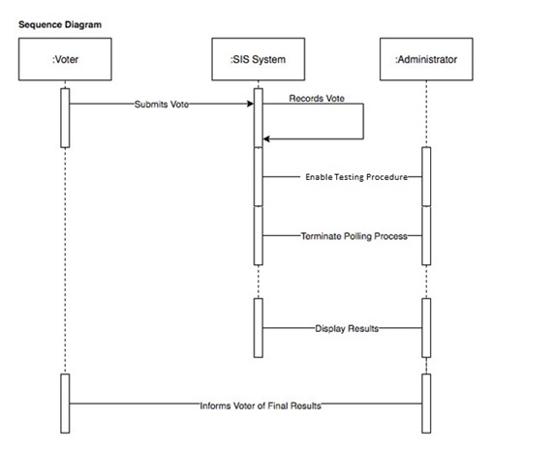

Figure - Sequence Diagram

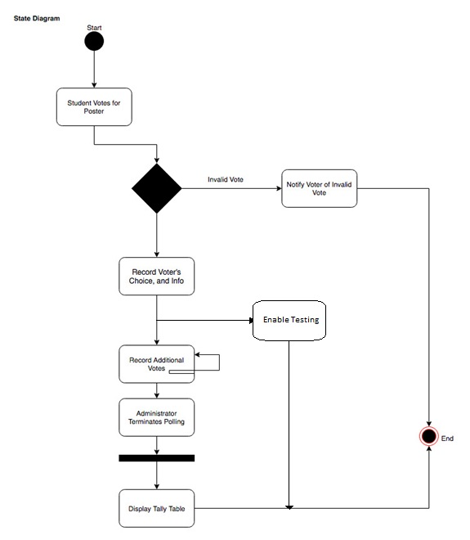

Figure - State Diagram

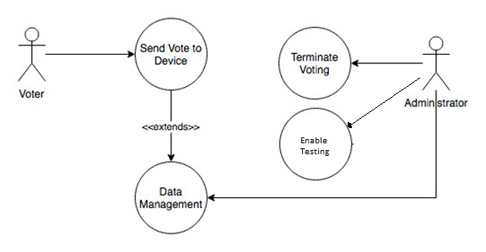

Figure - Use Case Diagram